Problem Statement

Link: https://acadgild.com/blog/transactions-in-hive/

Refer the above given link for transactions in Hive and implement the operations given in the blog using

your own sample data set and send us the screenshot.

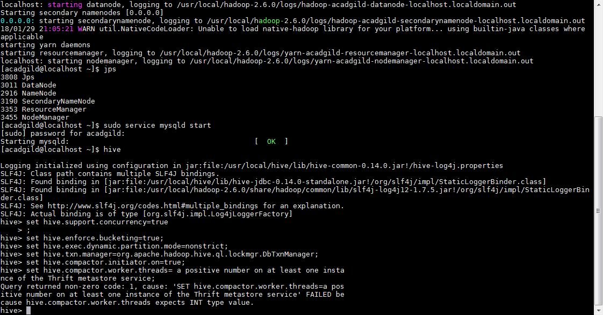

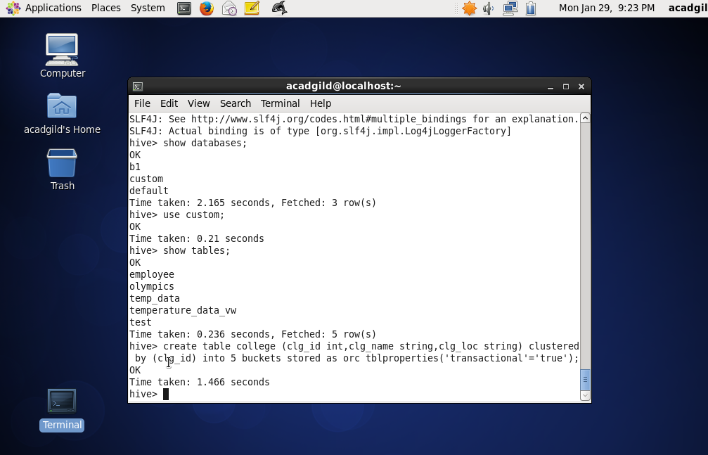

Data insertion into table

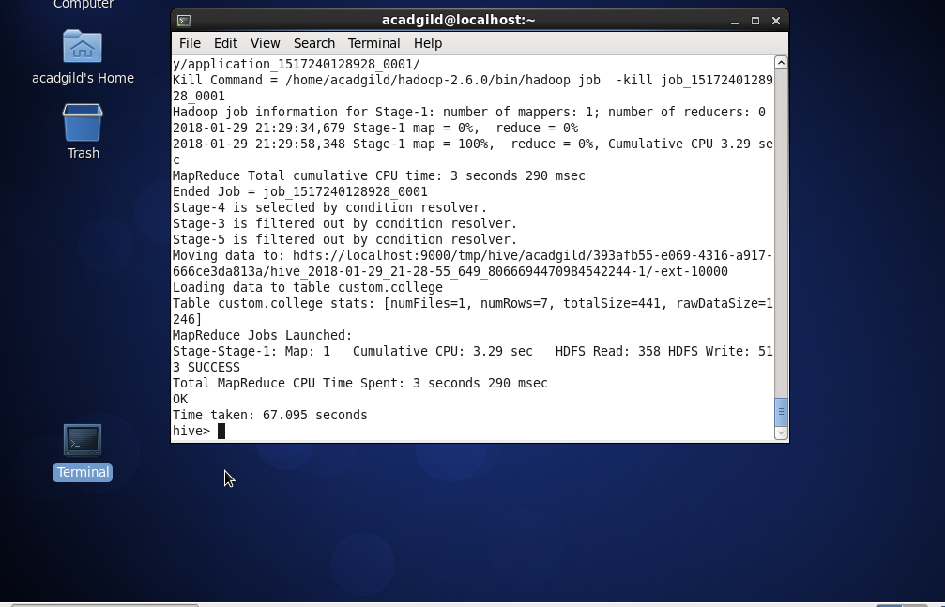

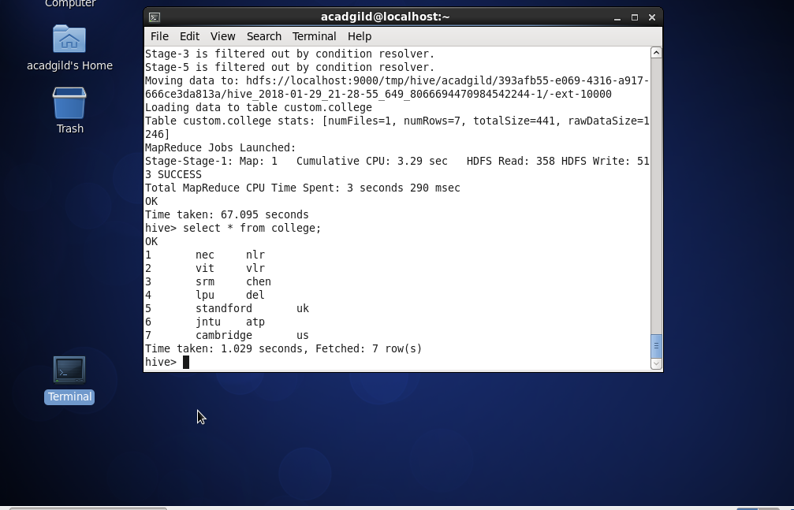

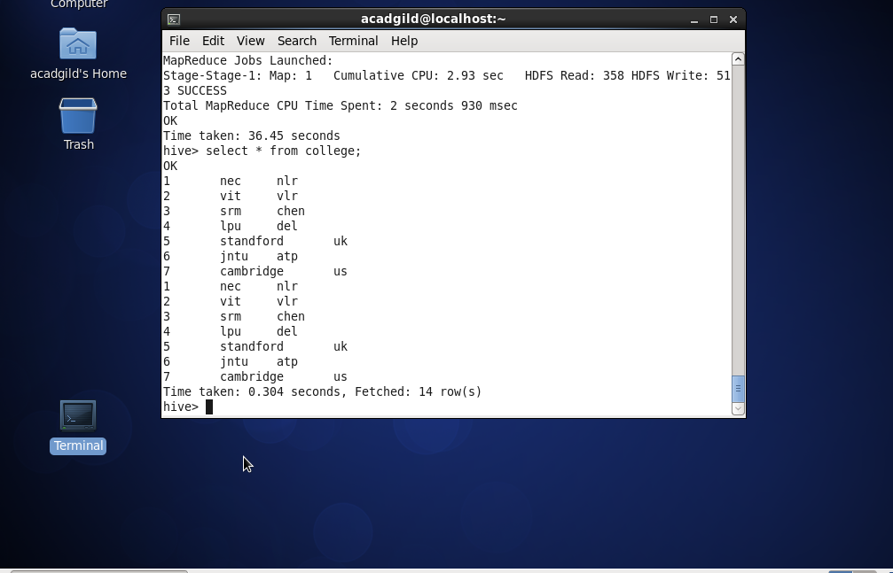

Updating the Data in Hive Table

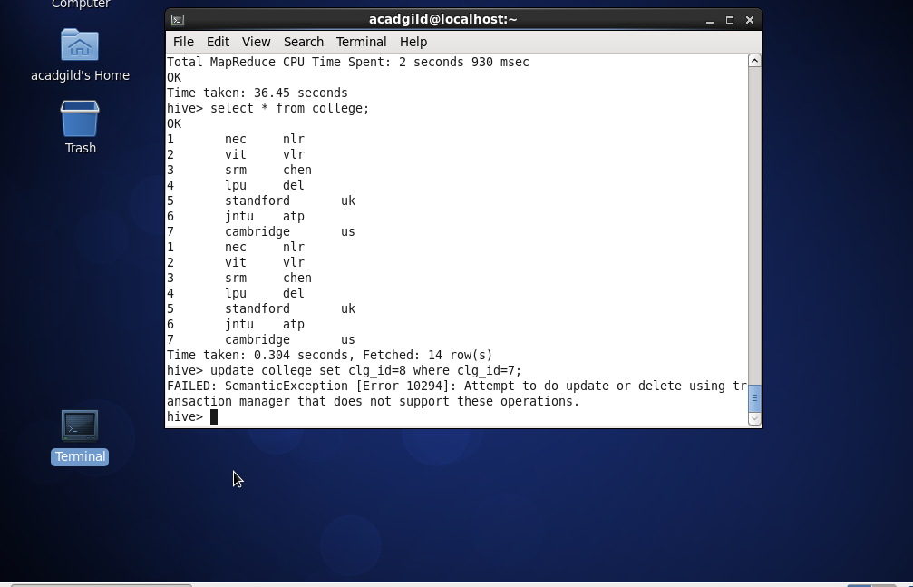

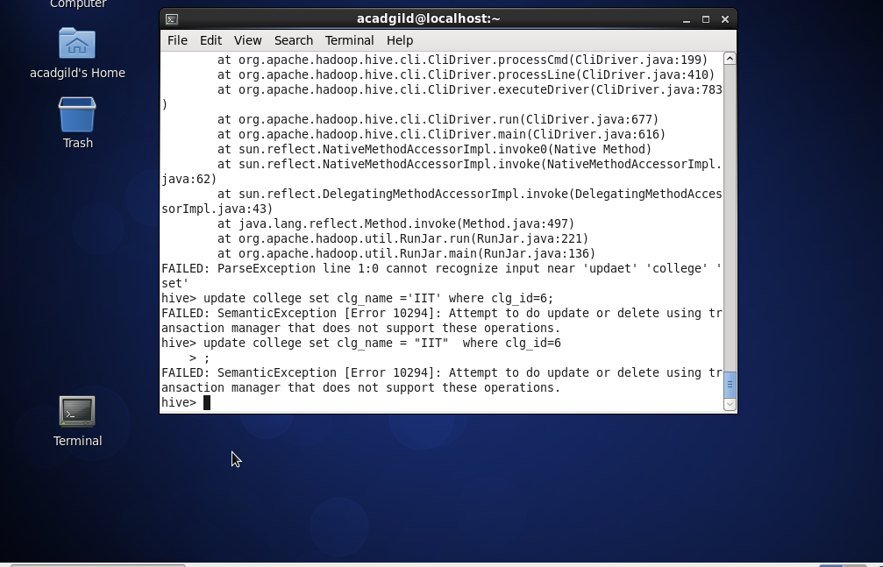

## Deleting a Row from Hive Table

## 